Groubndcrew AI Stage 1

- Go to https://www.microsoft.com/en/microsoft-copilot/microsoft-copilot-studio?market=af

- Click ‘Sign In’ on the top right corner and use your demo credentials provided by MSFT to sign in

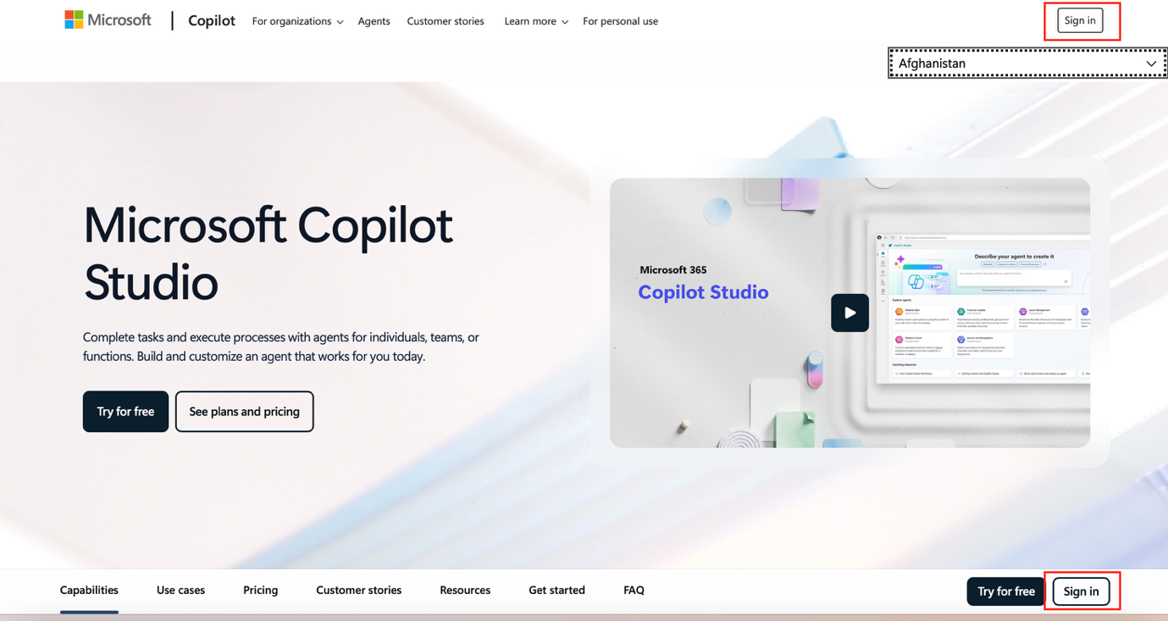

- You will see this page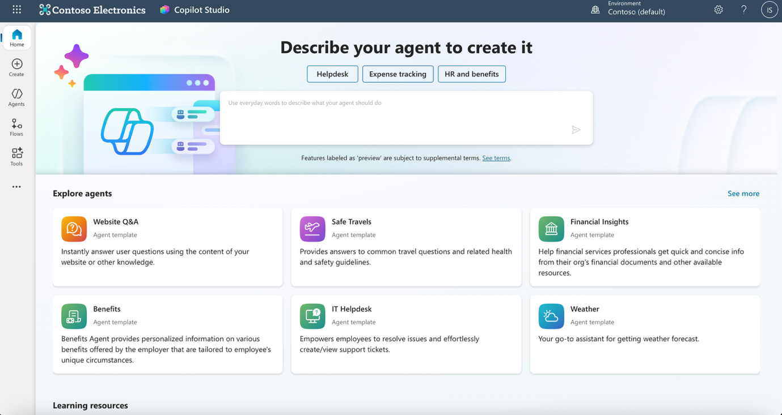

- Great! You have your Copilot Studio logged in and ready to build!

